# Introduction



**Ministry in the Diocese of Blackburn**

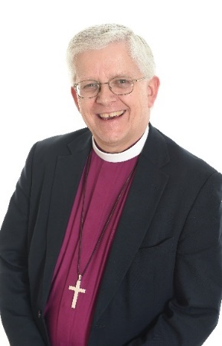In the Diocese of Blackburn we profoundly believe in the difference that the Gospel makes to peoples’ lives and so have a deep commitment to building healthy churches which can transform the communities in which they are set. We are looking for clergy of all backgrounds and traditions who share our passion for making a difference in the name of Jesus Christ.

 ‘Vision 2026’ is a bold and ambitious strategy which presumes that growth is what God wills for his church and which seeks to deliver growth through making disciples, being witnesses and growing leaders. You can read much more about this on other pages.

Our Diocese serves an area of extraordinary variety, from the stunning countryside of the Trough of Bowland to the former mill towns of East Lancashire, from the University cities of Preston and Lancaster to the seaside towns of Blackpool and Morecambe, from elegant villages to Presence and Engagement Parishes, there is something for everyone. We have Parishes of all traditions and are strongly committed to the principle of mutual flourishing. We are also seeking to grow 50 new congregations by 2026 so need people who are gifted as pioneers and evangelists.

If you think that the Church of England is at its eventide and that decline is inevitable, then these pages are probably not for you. But if you believe that all things are possible if we trust God, love his people, pray fervently, preach the Gospel of salvation in Jesus Christ and work hard, then we would love to hear from you. Even if none of the jobs on these pages seem quite right, get in touch anyway. And please be assured of our prayers as you seek to discern where God is calling you.



The Bishop of Blackburn  
*The Rt Revd Julian T Henderson*

# 